**Assignment No:-65**

Name:-Suryawanshi Sangramsingh Sambhaji

Batch: - Delta - DCA (Java) 2024 Date:-25/8/2024

**1. Find the Maximum Element: Write a Java program to find the maximum element in an array.**

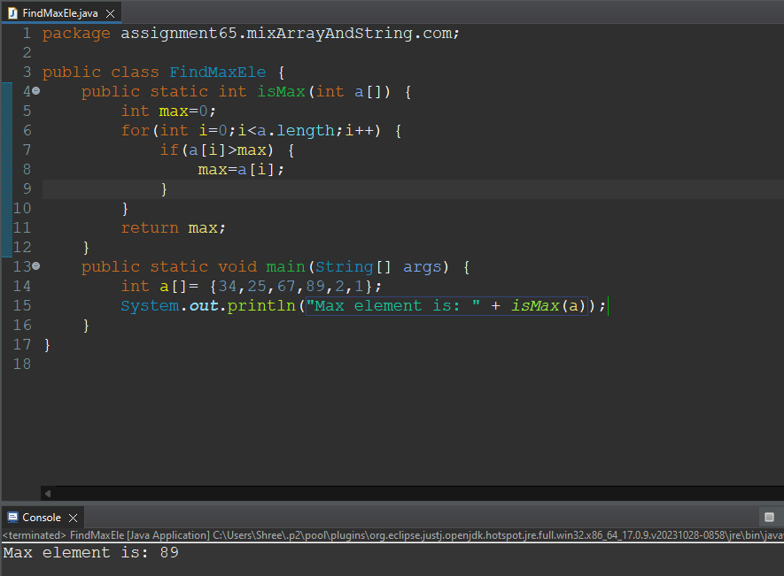

**2. Reverse an Array: Write a program to reverse the elements of an array.**

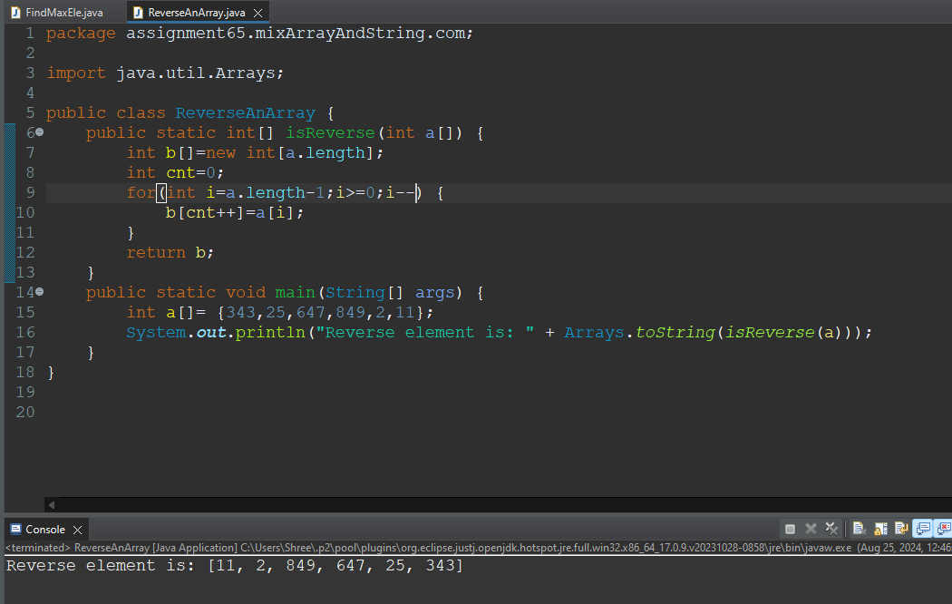

**3. Rotate an Array: Implement a function to rotate an array to the right by k steps.**

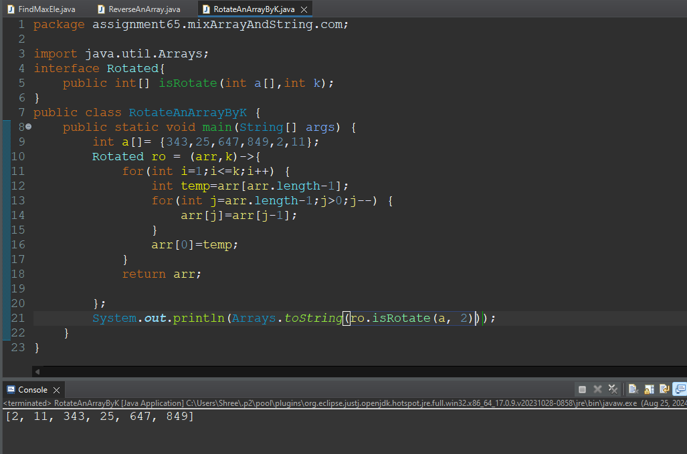

**4. Sum of Elements: Write a program to find the sum of all elements in an array.**

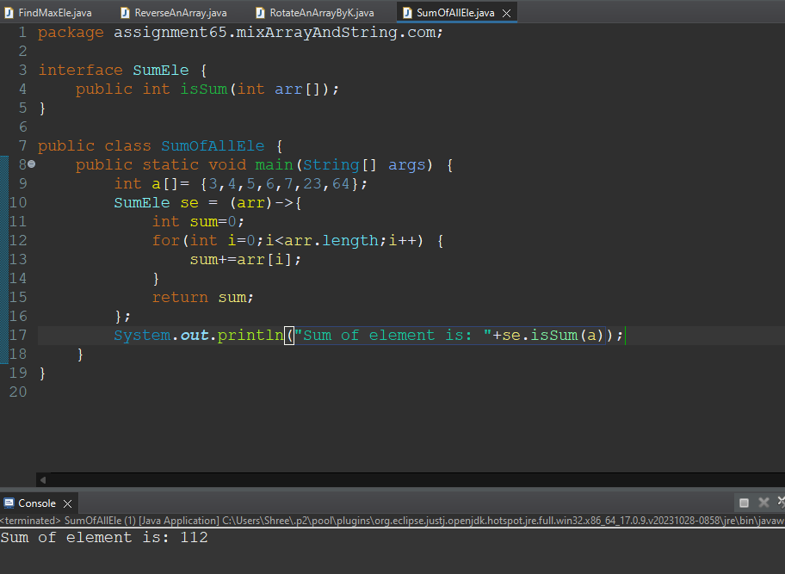

**5. Second Largest Element: Write a Java program to find the second largest element in an array.**

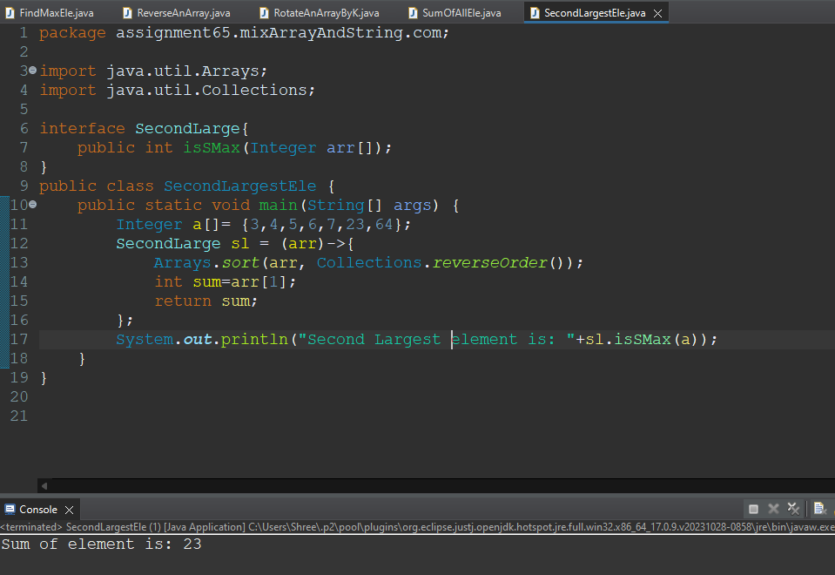

**6. Merge Two Sorted Arrays: Implement a function to merge two sorted arrays into a single sorted array.**

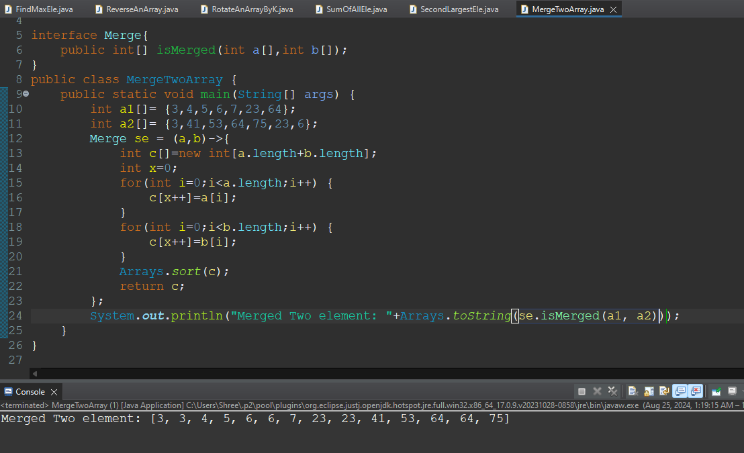

**7.Remove Duplicates: Write a program to remove duplicates from a sorted array.**

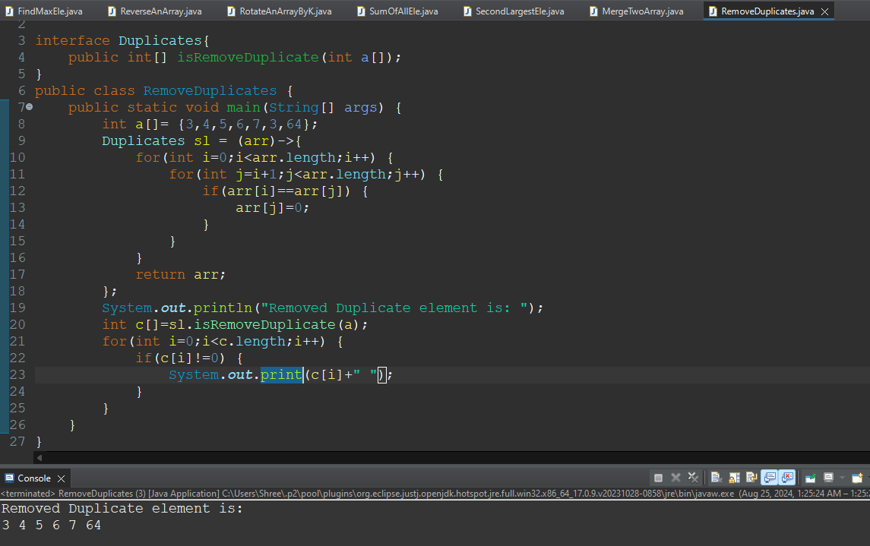

**8. Find Missing Number: Given an array containing n distinct numbers taken from 0, 1, 2, ..., n, find the one that is missing.**

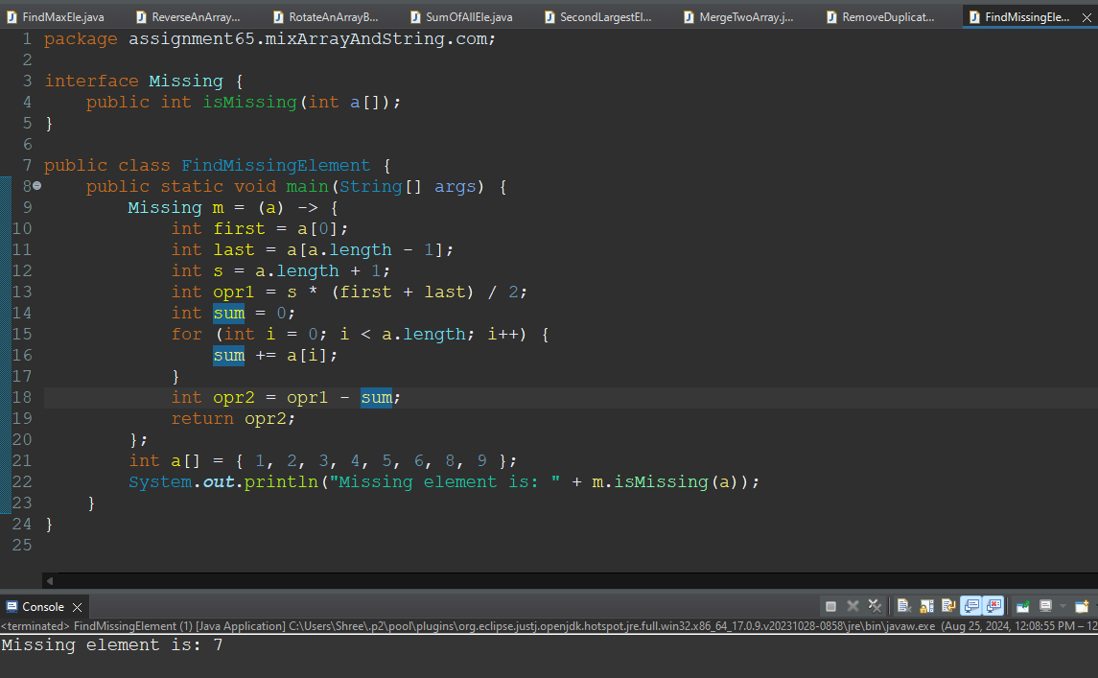

**9.Find the Intersection: Write a program to find the intersection of two arrays.**

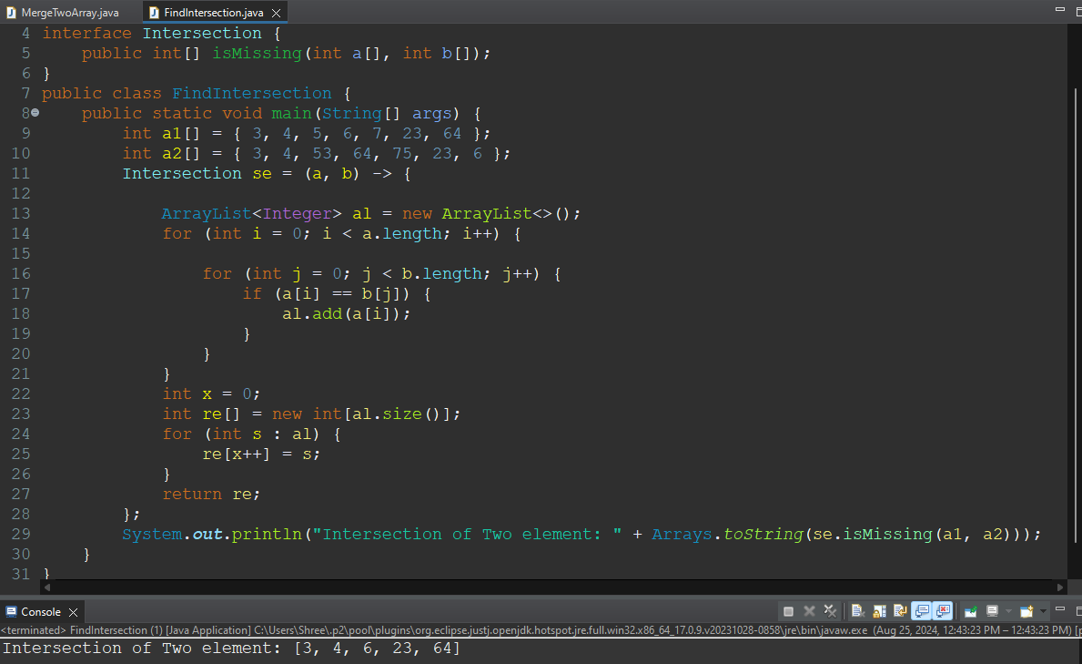

**10.Find Pair with Given Sum: Given an array of integers, find a pair of elements that sum to a given value.**

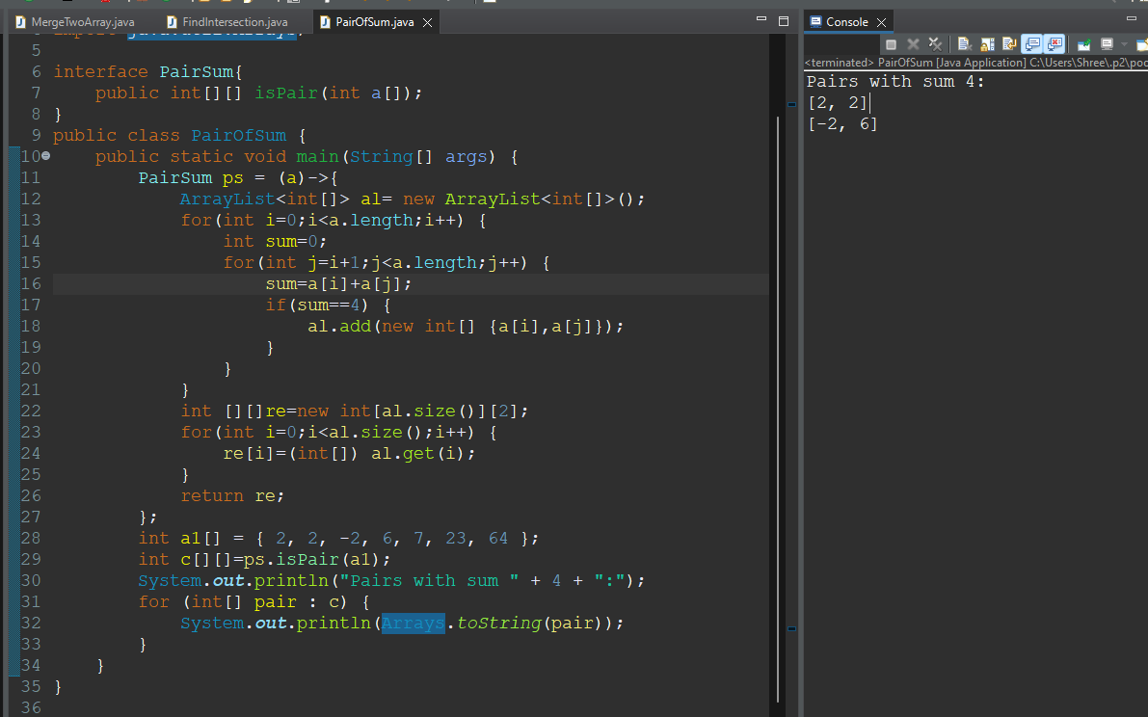

**11.Move Zeros to End: Write a Java program to move all zeros in an array to the end while maintaining the order of other elements.**

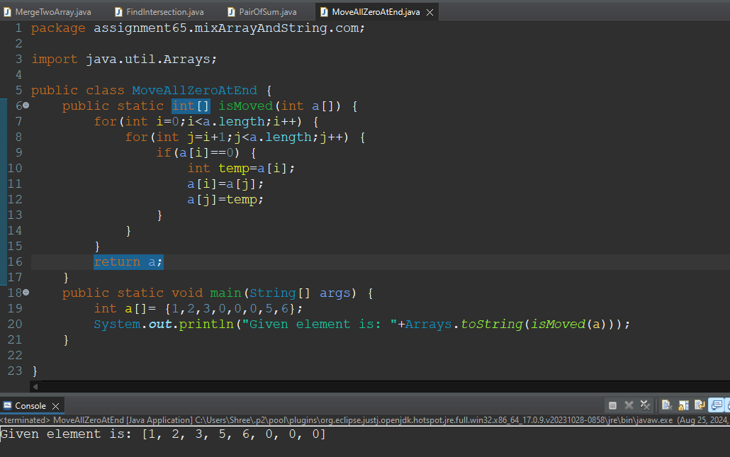

**12.Sort an Array: Implement a sorting algorithm to sort an array.**

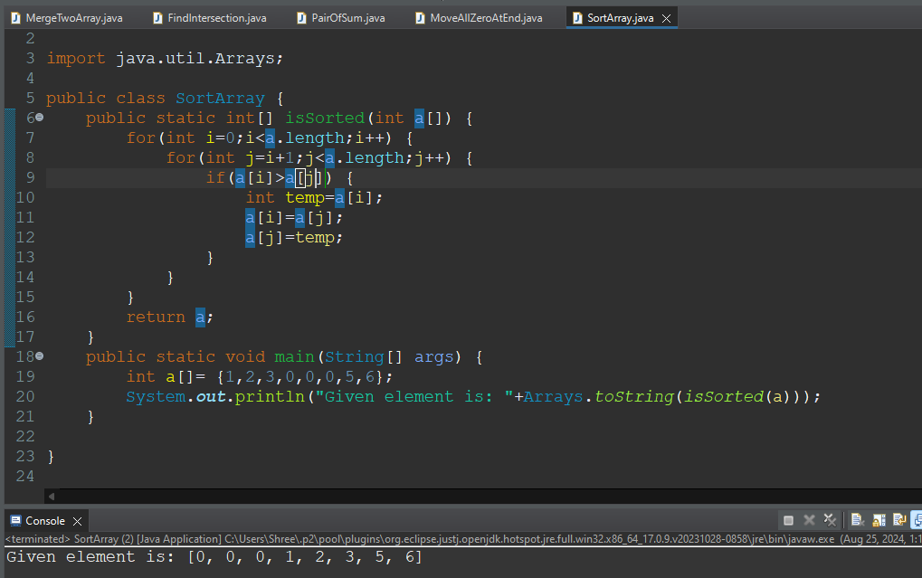

**13.Find the Majority Element: Write a program to find the majority element in an array (an element that appears more than half the time).**

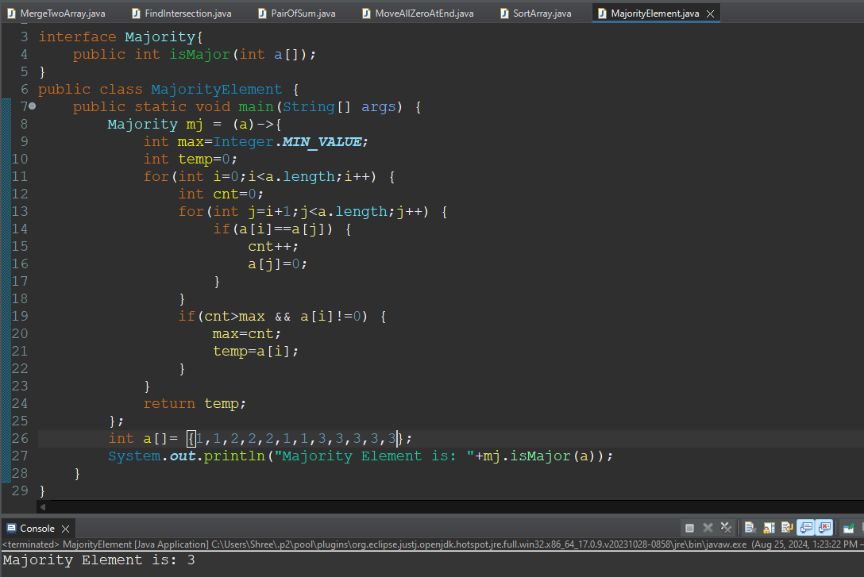

**14.Find the Contiguous Subarray with the Maximum Sum: Implement Kadane's algorithm to find the contiguous subarray with the maximum sum.**

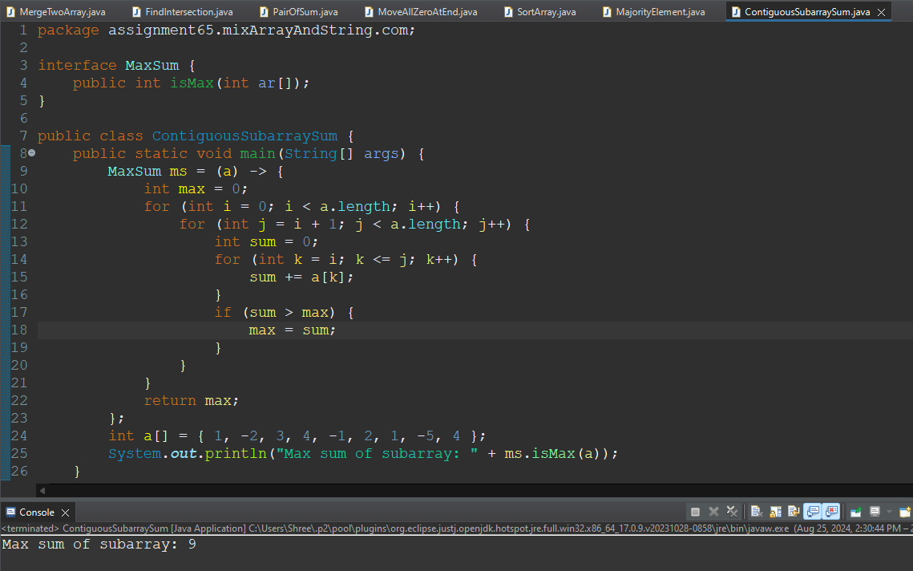

**15.Find the Smallest and Largest Elements: Write a program to find the smallest and largest elements in an array.**

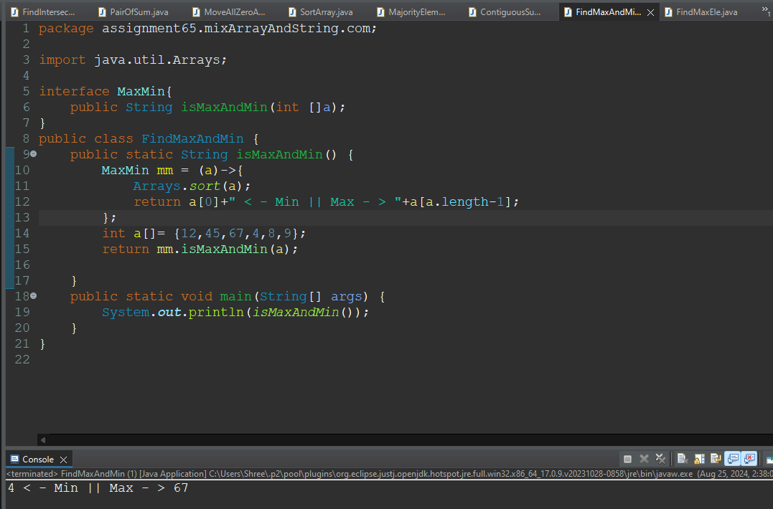

**16.Toggle Case of Characters: Write a Java program to toggle the case of each character in a string (convert uppercase to lowercase and vice versa).**

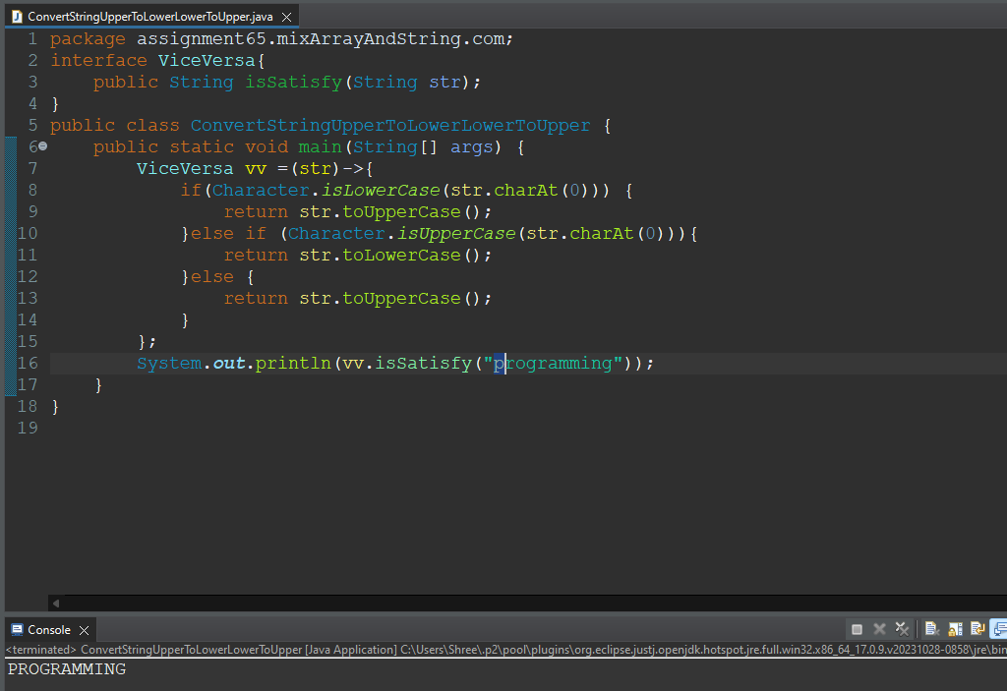

**17.Count Words in a String: Write a program to count the number of words in a given string.**

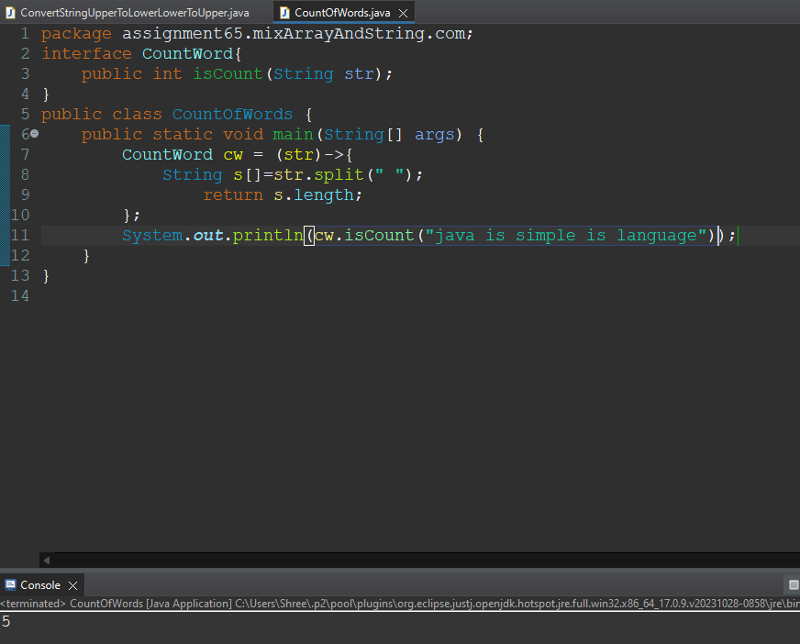

**18. Remove a Specific Character: Write a Java program to remove all occurrences of a specific character from a string.**

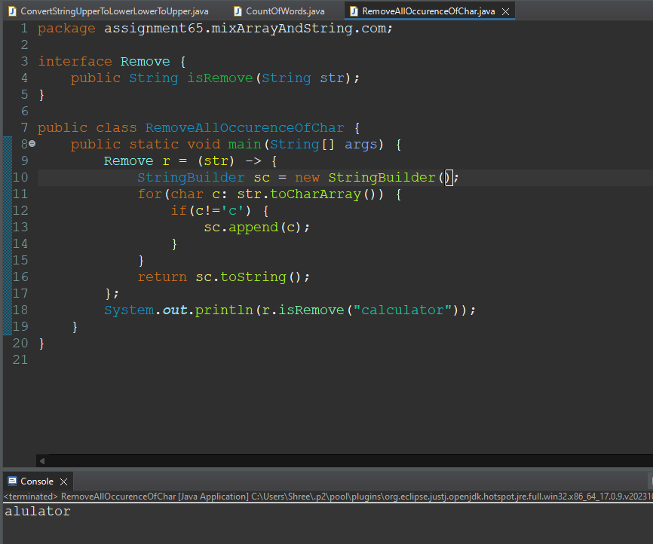

**19. Check if String Contains Only Digits: Implement a function to check if a string contains only numeric digits.**

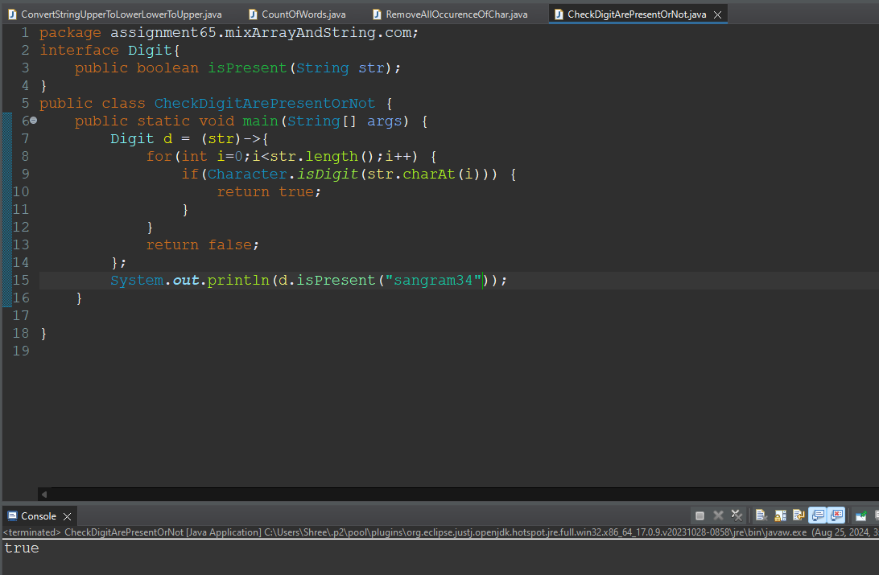

**20.Capitalize the First Letter of Each Word: Write a program to capitalize the first letter of each word in a sentence.**

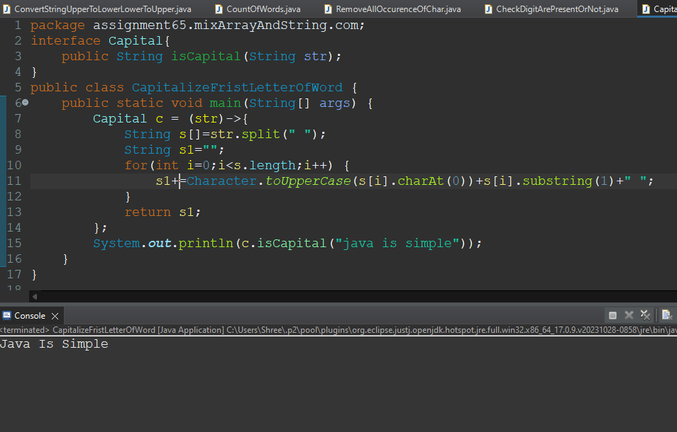

**21. Check if Two Strings are Permutations of Each Other: Write a Java program to check if two strings are permutations of each other.**

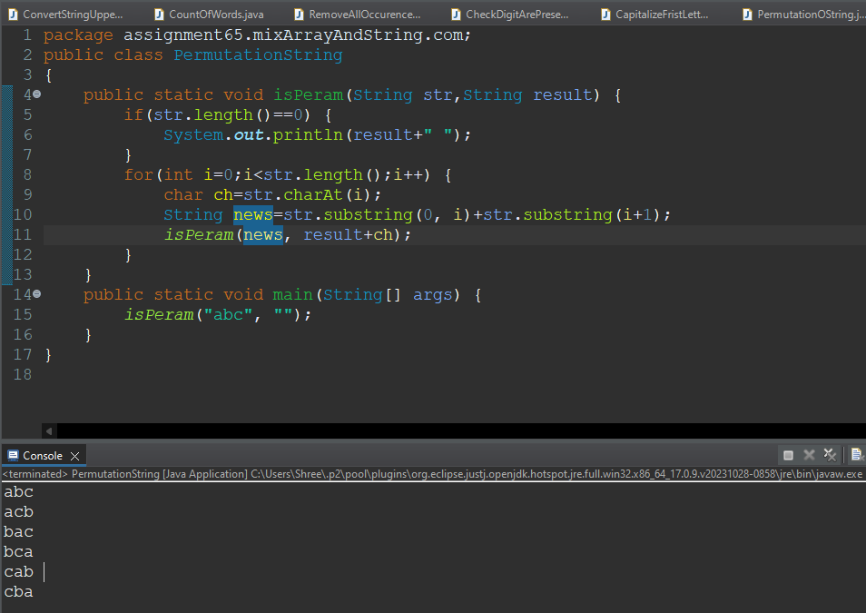

**22.Find the Most Frequent Character: Write a program to find the most frequently occurring character in a string.**

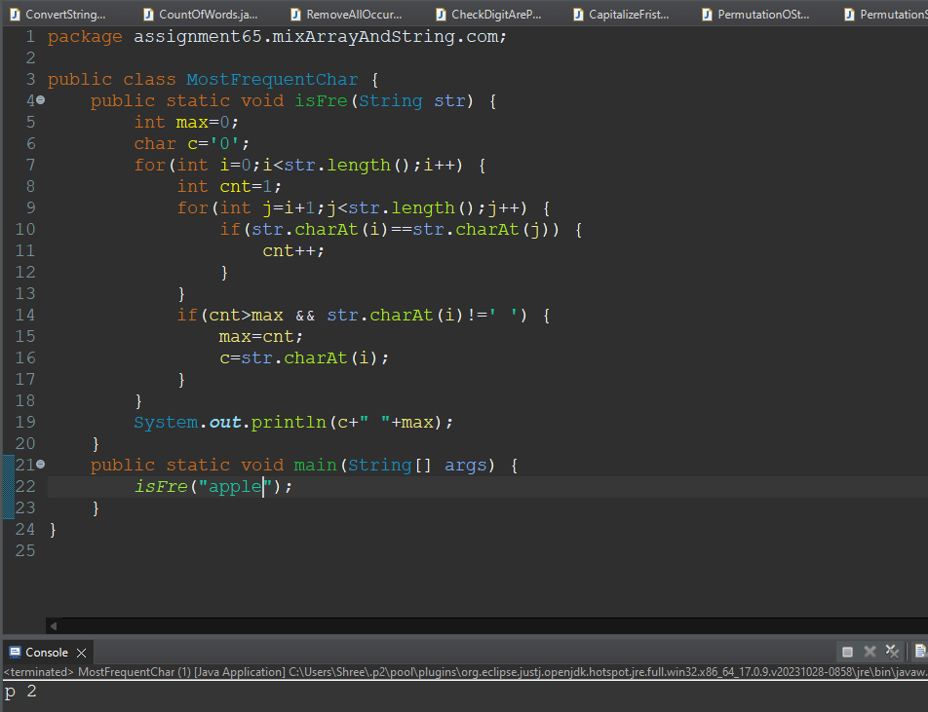

**23.Replace Spaces with a Specific Character: Write a Java program to replace all spaces in a string with a specific character.**

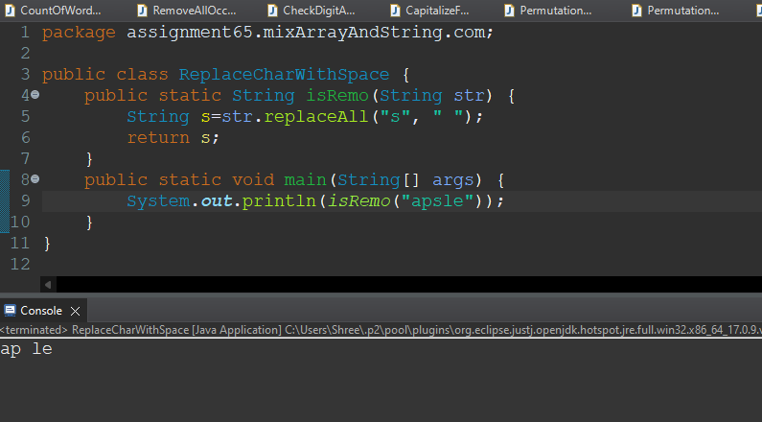

**24. Find All Substrings: Implement a function to print all possible substrings of a given string.**

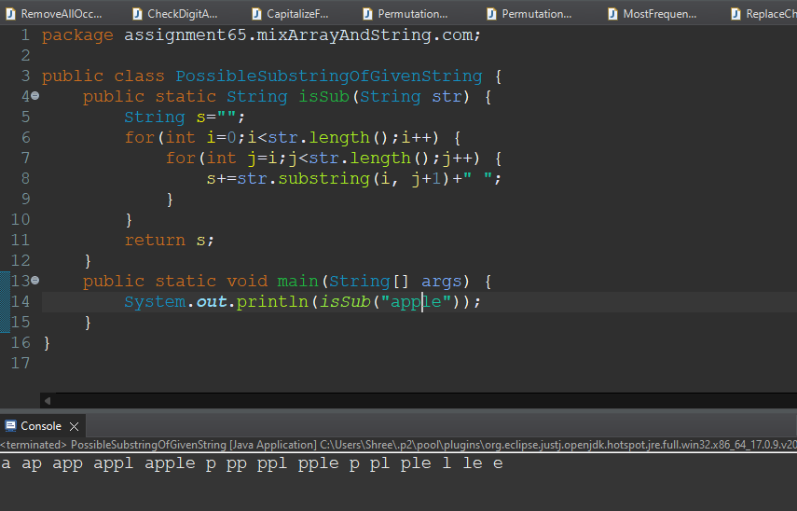

**25.Reverse Each Word in a String: Write a program to reverse each word in a given sentence while maintaining the order of words.**

